**How to create Multibranch pipeline in Jenkins | Multibranch pipeline tutorial**

Let us learn how to create multi branch pipeline in this article.

**What is Multibranch pipeline?**

 - Automatically create new pipelines for every Git branch in source version control.

- Enables different pipeline implementation for every branch. for e.g let us say you want to have CICD pipeline for master branch and only CI pipeline for develop branch.

- an automatically discover new branches in the source control (GitHub or any SCM) and automatically create a pipeline for that branch.

**Create Jenkinsfile first**

Please follow the <https://www.coachdevops.com/2020/03/how-to-create-jenkinsfile-how-to.html> above to understand how to create Declarative pipeline - Jenkinsfile.

**How to create multibranch pipeline**?

 Go to Jenkins. Create a new Item. give a name like myMultiBranchPipelineJob

[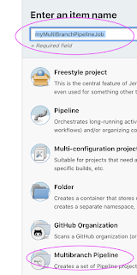](https://1.bp.blogspot.com/-dOgbKNv3B9Q/YGXq27BJmLI/AAAAAAAADWg/J5l3FTgP7Yo5nq89UkFQhebGkp-pbRewACLcBGAsYHQ/s1366/multi.png)

Click ok

Click branch source,  Add source, Add git.

Give your repo URL which has Jenkinsfile already.

[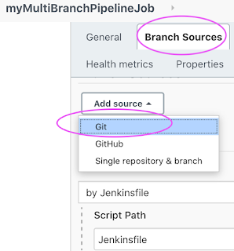](https://1.bp.blogspot.com/-GzIXoFEB9cs/YGXroYK6juI/AAAAAAAADWo/afKL-MNgQsAYH0anpPQ7_fWtx8F-NCqiwCLcBGAsYHQ/s706/git%2B.png)

Give your Git repo url, credentials. select credentials from the drop down.

[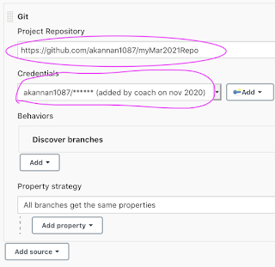](https://1.bp.blogspot.com/-IrCNGFrnAZA/YGXr58aJyGI/AAAAAAAADWw/Wqvj7g74AgwZAeUXpnwJG7-H14T9bRACQCLcBGAsYHQ/s996/git%2B2.png)

Click apply and Save.

Now the pipeline job will automatically scan and creates pipeline per branch.